WEBSITE FAQs: Total Triage at Our Practice

1. What is Total Triage?
- Total triage means that every appointment request is reviewed by a clinician before an appointment is booked. This ensures you are directed to the most appropriate clinician and appointment type for your needs as well as improving continuity of care.

2. Why has the practice introduced Total Triage?

We want to ensure all patients receive:
- Safe and timely care
- An appointment with the most suitable healthcare professional – including continuity of care
- Clinical prioritisation based on need
- Better overall access to appointments
- Total triage helps us achieve these goals consistently

3. Will I still be able to see a GP?
- Yes. If a GP is the most appropriate clinician for your symptoms, you will be offered a GP appointment. In many cases, other clinicians such as nurse practitioners, pharmacists, mental health workers or physiotherapists may be better placed to help.
- You may also be directed to a pharmacy where appropriate for more minor illnesses

4. Why do you need information about my symptoms?
Providing information helps our clinical team understand your needs so they can:
- Prioritise urgent issues
- Offer the right type of appointment
- Direct you to the right member of the clinical team
- This improves safety and reduces unnecessary waiting

5. Who decides what type of appointment I get?
A GP reviews your request and decides the safest and most effective option, whether that is:
- A face-to-face appointment (routine/ same day)
- A telephone consultation
- Self-care advice
- Referral to another service
- Redirection of request to the appropriate administration team where an appointment is not necessary

6. Will this delay my care?
- No. Total triage often reduces delays by making sure urgent issues are managed quickly and routine matters are allocated appropriately. It also prevents patients being booked with the wrong type of clinician.

7. What if I cannot use online forms?
- You can still contact us by phone or in person. Our reception team will ask the same brief questions and enter the information for you ensuring that your requests are triaged and allocated on clinical need.

8. Is my information confidential?
- Yes. Any details you provide are handled securely and only shared with staff directly involved in your care.

9. Can I request a specific clinician?
- Where appropriate and where capacity allows, we will always try to accommodate requests for continuity, especially for ongoing or complex issues.
- There may be times that this is not possible due holidays/ sickness/ demand and clinical need

10. What if my problem worsens while waiting?
- If your symptoms change or become more urgent, please contact us again. A clinician will reassess your request.
- If you feel that you need urgent medical attention, please contact us to update us about your change in condition, contact 111 online or the phone OR in medical emergencies call 999

11. Can I submit multiple online consultations in a day?
- We encourage patients to choose the right service for their condition (see below image for support of where to go for what problem)
- There is no need to complete multiple online consultations for the same problem, this does not speed up the response & you will not get an appointment quicker
- Follow the link for self-care & self-referral options - Self Care & Self Refer « Trinity Medical Centre

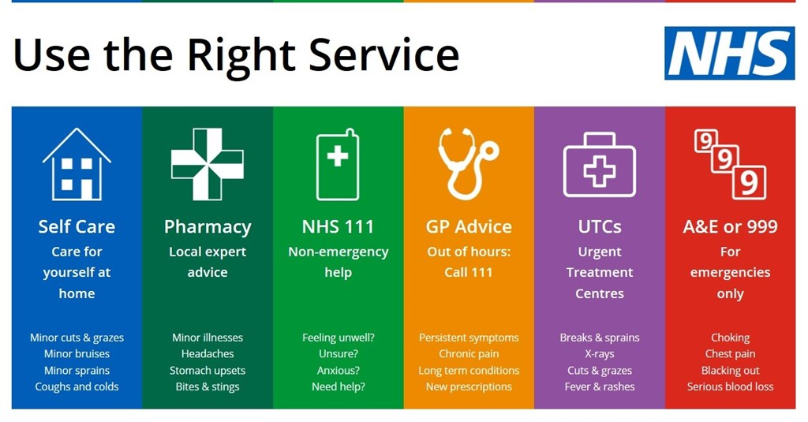
12. How quicky will someone respond to me
- The practice will aim to respond to you within 24 hours of submission unless submitted on a Friday (you will be contacted by the end of the working day Monday). This does not mean that you will have an appointment within 24 hours. What it does mean is that you might be contacted for further information, directed to a more appropriate route of care or phoned/ sent a booking link to book an appointment with a clinically appropriate person for the condition that you are presenting with
- If you feel that you need urgent medical attention outside of our core hours of Monday – Friday 8.00 – 18.30, contact 111 online/ phone OR in medical emergencies call 999

13. What if I do not like the answer or outcome that I have received?
- Please remember that one of our GPs will be reviewing the online consultations that we receive, and they will make a clinical decision from the information that you have documented. If they feel that further information is required to help them make that decision, they will be in contact with you.

14. Will this change be reviewed?
- Yes, we will carry out regular reviews of this change to measure the impact that it has had
- We will also be offering bookable sessions to come and discuss with us/ share feedback – dates to be confirmed

